AASCB Nomination Submission – President Elect
Dr. Michelle Santiago – Pennsylvania

STATEMENT OF QUALIFICATIONS
I was a first generation college student and am a Puerto Rican woman with a doctorate degree in Clinical Psychology. Clearly, while I trained to be a clinical psychologist, I have never identified as a psychologist. I am a (PA) Licensed Professional Counselor, National Certified Counselor, Certified Clinical MH Counselor, Certified Clinical Trauma Professional, and Certified in the practice of DBT. Previously, I was a Title IX investigator and a certified civil rights investigator level three.

I have worked as a MHP since 1996. I am currently the Chair of the PA State Board of SW, MFT and PC. I previously served as Vice Chair, as a probable cause hearing member, and reviewer of continuing ed providers. I have worked on drafting policy, evaluating fairness in procedures, and heard both disciplinary and discrepancy cases. I’m currently the VC of the awards committee for the IARTC, where I had previously been on their ethics committee. My other leadership contributions include serving the society for psychology of women in the role of professional representative as part of their executive committee. I was a founding member of the Clinical Supervision Research Collaborative and have been on local community boards of directors and on committees at my University for everything from faculty dispute resolution group to faculty secretary to assessment standards for accreditation. I’ve been at Moravian University for 14 years.

I am an Associate Professor of Clinical Practice and Director of Clinical Training at Moravian University in the MA Clinical Counseling Program. I practice as a pro-bono clinical supervisor -for the under-represented post grads accumulating hours towards licensure. My personal qualifications are: I am plain spoken, I can be counted on to show up and show out with integrity, civility, and honesty; I am dedicated, experienced, knowledgeable, have a good sense of humor, know how to cut through the mess and get to the point, and truly, life hands me lemons- I make lemonade.

GOALS
My intentional primary goals are to continue to make AASCB the go to organization for the counseling community. Other goals (in no particular order)

  - Counselor Identity and who defines it
  - Inclusivity of AASCB membership
  - Conference accessibility
  - Board administrators- what can we do for them?
  - Member Board chair trainings offered by AASCB
  - Boards that are not yet members- and why not?
- Stats and data from member boards
- Composite boards and homogenous boards- how are we a diverse resource for their diverse needs?
- What other partnerships are needed when we think outside of the box? Who is really invited to the table?
- MPCAC, CACREP, and Health Service Psychology Masters Degree Programs- what is up and yes, we still need to talk about it

PROFESSIONAL AFFILIATIONS OTHER RANDOM STUFF (also in no particular order)
PA State Board of SW, MFT and Professional Coun 2016 National Register Associate micro certificate-Clinical Suicidology 2020
International Assoc of Trauma Counselors 2022 IOCDF Behavior Therapy Training Institute 2011
APA Div 35 Reproductive Issues Committee 2021-pres Qualified Administrator: Intercultural Development Inventory® 2020
Liaison to APA D35 Trauma psychology 2016-2019 NE Region Disaster MH Responder 2015
Society for the Psych of Women Exec Com/Rep 2015-2019 TN-LPC, MHSP (retired) 2006
Association for Student Conduct Administrators 2017 Trauma Focused Cognitive Behavioral Therapy 2016 APA Master’s Training Issue Task Force 2017 APA D35 Service Award 2019
University of New Mexico Mentor Institute 2016-pres Moravian Univ. Unsung Hero 2022
APAGS LGBT+ Mentoring Program team 2016-pres Moravian Univ. Faculty Spotlight 2016
APA Division 44-Society for the study of LGBT 2012-pres Moravian Univ. Outstanding Leader 2015, 2017
APA Division 35-Society for the Psych of Women 2012-pres

ADDITIONAL LEADERSHIP EXPERIENCE
National program peer reviewer:
Summer School of Personality Science (SSPS) 2022
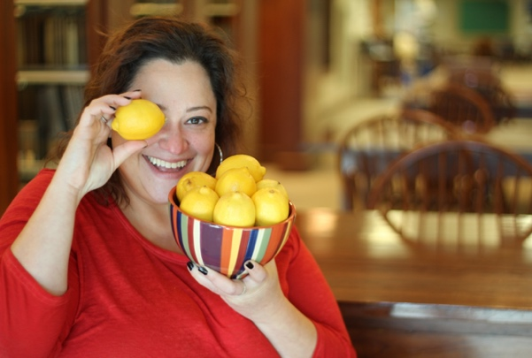
APA Div-35 Psychotherapy with Women Awards 2018-2020
Division 35 program proposals for APA Chicago 2019
Inaugural Convention of AAPI Feminist Psychologists 2018
Rocky Mountain Assoc of Counselor Eds National Program 2018
National Latino Psychological Association National Program 2018.
Funding proposals by APA graduate campus reps 2017
ASCA Annual Conference 2017
APA National Convention 2017
APA D44 Bisexual Foundation 2016, 2018
University of New Mexico Mentor Institute 2016, 2022
National Latino Psychological Association National Program 2016
APA D35 Conference 2015, 2106
Association for Women in Psychology 2015, 2016
National Multicultural Conference and Summit 2015-2017
International Women’s Summit 2014
APA D44 Program Committee 2013
National Planning Committee for Phila TransHealth Conf 2013, 2016, 2018
Peer reviewer for numerous textbooks 2016-2021

