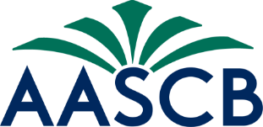

2023 Annual Business Meeting Agenda

- Call to Order Robinson
- Approval of the Agenda Robinson
- Approval of 2022 Minutes Robinson
- President’s Report Robinson
  - State Board Hangouts
  - Affiliate Meetings
  - Counseling Compact
  - Board Training Modules
  - Committee Reports
  - 2024 Conference
- State Board Reports Robinson, State Reps
- Treasurer’s Report Ellison
- Association Management Report Grayson
- Affiliate Reports Robinson
Conclusion of Business Meeting, Part I
- Roll Call/Certification of Delegates Collazo
- Nominations and Elections Robinson, Doyle
- Unfinished Business Robinson
- New Business Robinson
- Closing Remarks Robinson
- Adjournment

